**Status checkpoint**

|  |  |
| --- | --- |
| **Project Members** | **Assigned Task/s** |
| Bertolano, Stemely Joy S. | Documentation |
| Capistrano, John Robert C. | Back-end |
| Canimo, Christine V. | Front-end |
| Guzman, John Patrick L. | Front-end, Documentation |

**Functions/Tasks done:**

Our task for this week is to develop the static design but unfortunately we haven’t able to finish the design, so this is our partial static design.

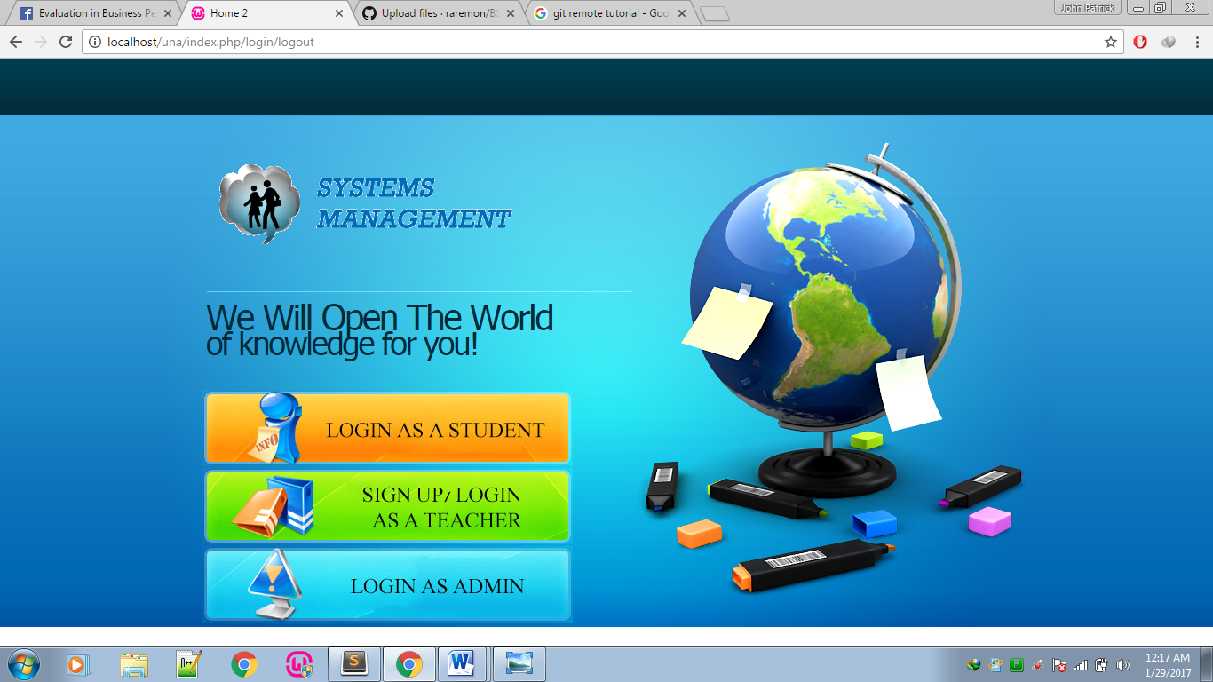

* **Figure 1:** Login page

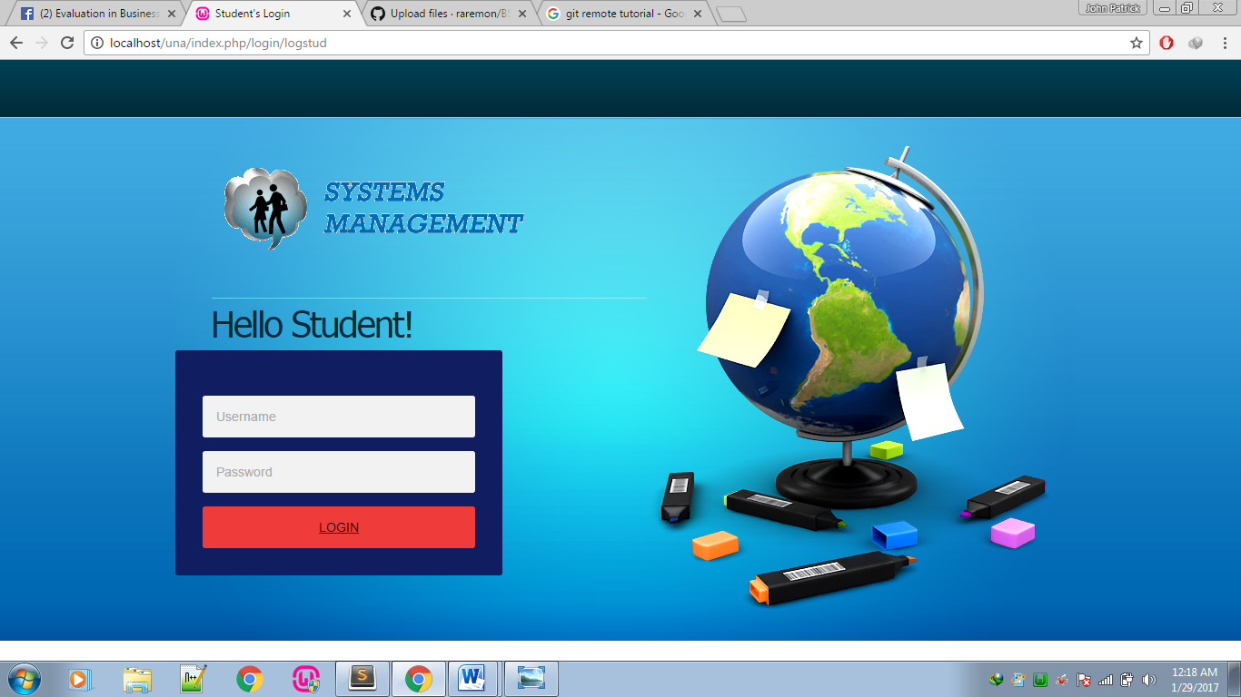

* **Figure 2:** Login page (Login Student)

**Note:** The login page is the same as the 2 pages (login teacher and login admin)

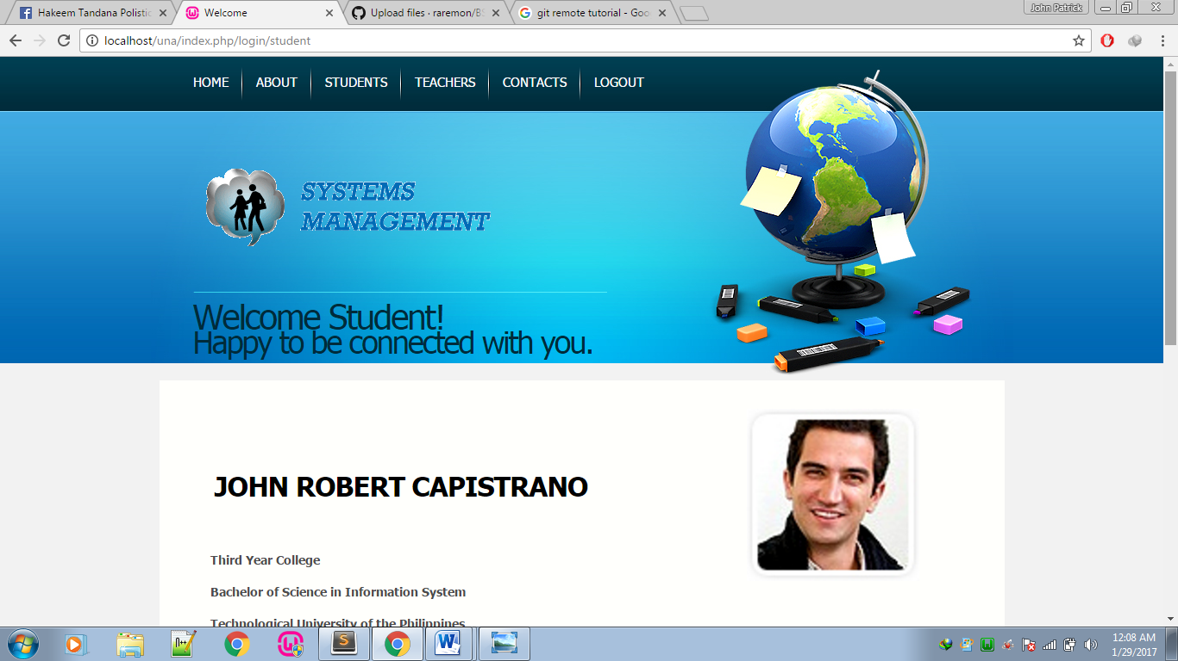

* **Figure 3:** Home page of student

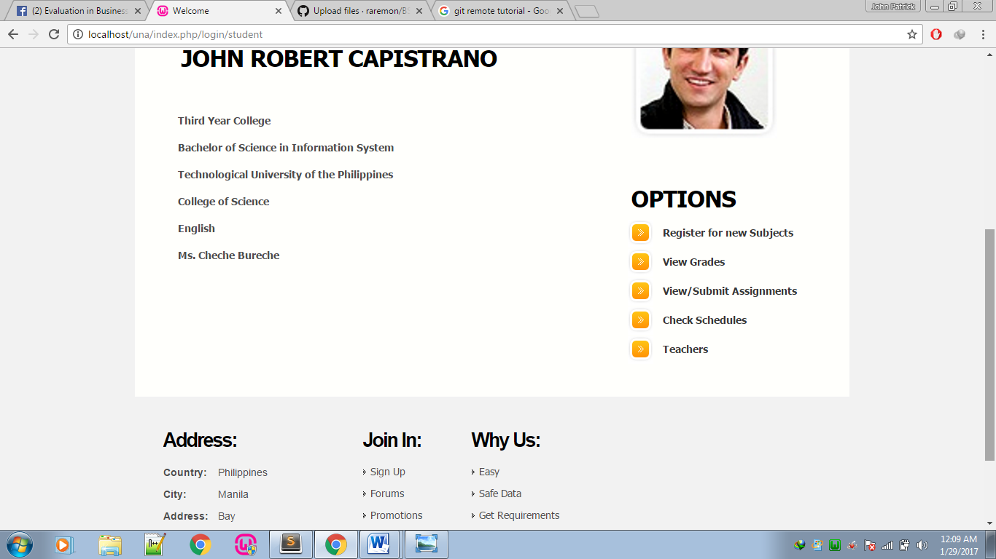

* **Figure 4:** Home page of the student (cont.)
* Options functions
* Register for new subjects
* View grades
* View/Submit Assignments
* Check schedules
* Teachers
* About page
* Logout button
* Student page
* Teacher page
* Contacts page

We have created only these set of pages for this week’s task.

**Next set of task/s for Next Week**

* Finalizing the static design
* Creating CRUD(Create, Read, Update, Delete)